**Prerequisite: -**

By default, add one admin user to the database table. So, the first time that an admin user login into an application and creates users and admin users.

**Requirements: -**

Users can log in using credentials Email and Password in the application. Then show the logged-in username at the right side of the page and the logout link. Only admin users can add another user as well as admin users. Show a message when the user or admin is added successfully and send a welcome email to the user with his application credentials along with the application login URL. Only Admin users can resent welcome email individuals or all users or admins by selecting all checkboxes from the manage users’ page. Normal users only view the users' list and are unable to resend emails to any users or admins by application. Please track the email sent date and resend the email history (Recipient user id, email sent user id, Date Time).

**Expected Implementation: -**

Header, Menu- Create User Page, Manage Users Page, and Footer.

Use MVC Area Concept: -Use the area concept as of now only for the User module but in the future, we will add different modules so use the Area concept.

Authentication (use session): - if an admin user logged in to the application, then only show the manage user page and create user page otherwise redirect to the login page.

Authorization: - Normal users do not have the right to add a user page and only view the manager users list and are unable to resend emails from the manage user screen.

**Use Technologies, Database, or languages: -**

Language- Asp.net MVC and jQuery.

Database: - SQL server.

Use Web API for database communication and Stored Procedures.

Send email use open source smtp like Hotmail or other you like it.

**Page details: -**

**1.Create User-**

Below all fields are required except the Admin rights checkbox (always optional) and mobile number optional only when the email option is selected.

**FirstName**: - Min 2 characters and max 20 characters. Allow alphabet along with allowing special characters & . ' -

**Last Name**: - Same as First Name

**Option (Radio button): - Email or both** –

 if the email option is selected then email is a required field and the Mobile phone is optional if the user selects both options then email, and Mobile phone are required.

**Email**: - universal email validation

**Mobile Phone**: - 10-digit numbers

**Password**: - 6 characters allow alphanumeric as well as #, &,$,@

**Confirm Password**: - Not save this field value in a database table. only check the password and confirm the password same by jQuery. If not the same, then display the validation message.

**Gender** (dropdown list): - Male, Female, Other

**Admin Rights** (Checkbox): -

**Note: - Please submit the create a user page using the jQuery Ajax method.**

**2.Manage Users Page: -**

Just for Idea, I have shared the below screen for how the functionality works. You can design your own basic UI is sufficient. Here we need to remote paging and sorting on first name / last name column in ascending and descending order. It will be great if possible do filtering on first name column.

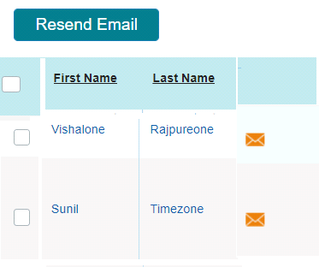

* Please display First Name, Last Name, Email, Mobile Phone, Gender, User Type, Created date, and Last sent email date as columns in the user list.
* Logged in Only Admin user can send email as below.   
    
  1. Individual users resend emails by send the email icon or link.  
  2. One or many select by checkbox and send an email by clicking resend the email.  
  3. Select the checkbox in the display in the column header then send an email to all users at a time.   
    
  Note: - Select all checkbox in the header then we will need to select all checkboxes that are selected in the user list or vice versa.
* Please show a confirmation box with appropriate text with username or user count (if many users).

Here all pages will need to implement in English language support but We just need to your thought or Idea (implementation approach) for below point.

**How will give support in multiple languages for this application?**